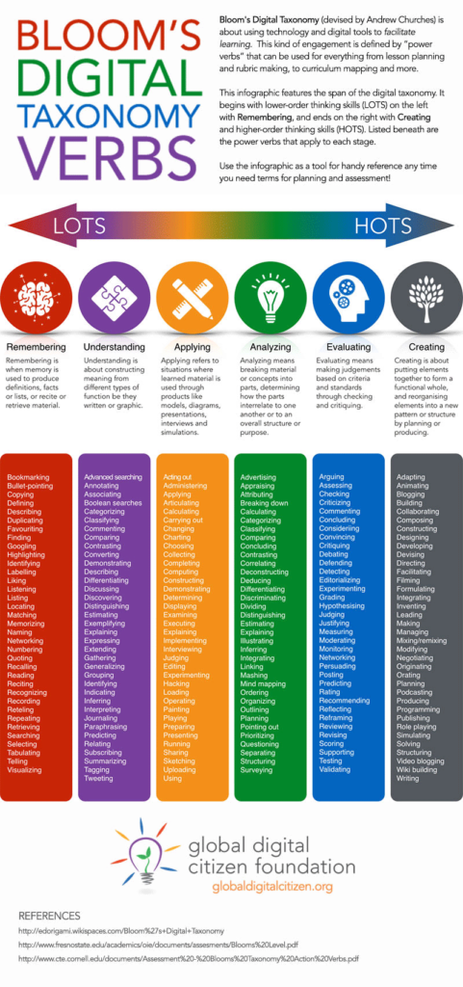
Marks attributed to each section:
Create: 1
Evaluate: 7
Analyse: 8
Apply: 10

Understand: 6
Remember: 6
Investigation rubric over the page. Cells with no verb bolded correspond to a Remember category mark. Validation is analysed on the pages following the rubric.
 | 4 | 3 | 2 | 1
Introduction /7 | Discusses how materials can be pure or combined from different components. Compares different methods and explains why distillation was the most suitable in this instance. | Discusses how materials can be pure or combined from different components. Describes different methods of separation. | Discusses how materials can be pure or combined from different components. | Defines what a material is and how it can be pure or combined from different components.
 |  | Identifies the purpose of this investigation, and demonstrates clear examples of how it can be useful in industries. | Identifies the purpose of this investigation, mentions industry but does not explain how it is useful. | Identifies the purpose of this investigation, does not identify uses in industry.
Materials and Method /3 |  | Designed method is coherent and easily followed. Materials are listed | Method is incoherent and hard to follow OR materials are not listed. | Method is incoherent and hard to follow. Materials are not listed.
Safety /1 |  |  |  | Classifies basic safety considerations, with specific safety precautions mentioned for chemicals used.
Results /2 |  |  | Results clearly classified in a format that is easy to understand. | Results presented but hard to follow/incorrect format.
Discussion /4 | Discussion covers all aspect:  -Interprets validity of results by comparing to expected results.  -Considers and examines possible errors.  -Evaluates the use of distillation as a method of separating salt from water | Discussion covers 2 aspect:  -Interprets validity of results by comparing to expected results.  -Considers and examines possible errors.  -Evaluates the use of distillation as a method of separating salt from water | Discussion covers 1 aspect:  -Interprets validity of results by comparing to expected results.  -Considers and examines possible errors.  -Evaluates the use of distillation as a method of separating salt from water | Discussion lacking in all aspects:  -Interprets validity of results by comparing to expected results.  -Considers and examines possible errors.  -Evaluates the use of distillation as a method of separating salt from water
Conclusion /2 |  |  | Conclusion reflects on data and the initial aim of the experiment. | Conclusion does not address the aim.
Resources /2 |  |  | At least 2 sources used, referenced in correct format. | <2 sources used, poorly referenced.
- In this experiment, we separated salt from seawater. Explain why we wanted to do this.
(1 mark)

- Our reason for performing a separation is different to the typical reasons most people try to separate complex mixtures. Using an example, explain one other reason people might want to perform a separation on a mixture
(2 marks)

- In this experiment, it would have been easier to simply evaporate the water off instead of distilling it. Explain why we instead chose to collect the water, reflecting on any additional data collected from that water and what that observation indicated.
(3 marks)

- One method of removing contaminants from water used by Water Corp to produce clean drinking water is sedimentation and decantation. Compare this method to distillation, and explain whether this could be a viable method to separate salt from seawater.
(2 marks)

- Below is a table of results for a group of students who performed 5 different evaporation experiments to determine the salt content in the dead sea.
Trial | Volume of Water (mL) | Amount of Salt (g) | Salinity (g/L)
1 | 500 | 613
2 | 250 | 1,152
3 | 500 | 587
4 | 250 | 1,098
5 | 500 | 632

- Calculate the salt content for the first and second trials in terms of the amount of grams per litre.
(3 marks)

- Complete the rest of the table.
(3 marks)
- Calculate the mean salinity for the dead sea based on the student’s data, and compare it to the measured salinity in 2011 which was 342 g/L. Evaluate whether this was a valid experiment.
(4 marks)

- In the evaporation experiment, it was noted that at one point the temperature of water was 105ºC, higher than the boiling point of pure water. Explain why, and predict whether you would expect the temperature to get higher, lower, or stay the same as the experiment went on.
(2 marks)

